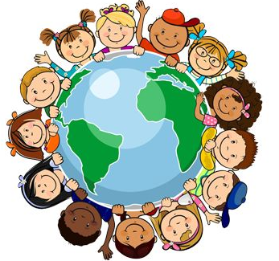
Useful websites …

- This is an excellent website to develop your children’s map skills https://www.ordnancesurvey.co.uk/mapzone/

- This website is full of lots of interesting information, including fun games to play
https://www.natgeokids.com/

- This website is full of craft ideas, quizzes and games to keep you busy at home
https://www.wwf.org.uk/

- There are new Geograpy lessons daily on BBC Bitesize
https://www.bbc.co.uk/bitesize/subjects/z2f3cdm

